

**Mattishall & Tudd Valley**

**Benefice Profile**



“Jesus came to seek and

to save the lost”

(Luke 19:10).

Will you come and help us do that?

**The parishes of**

**All Saints’, East Tuddenham; St Michael’s, Hockering;**

**All Saints’, Mattishall & St Peter’s, Mattishall;**

**St Mary’s, North Tuddenham;**

**All Saints’, Welborne; St Peter’s, Yaxham**

**Benefice Overview of the Mattishall and Tudd Valley group of churches:**

**East Tuddenham, Hockering, Mattishall,**

**North Tuddenham, Welborne and Yaxham**

Thank you for taking the time to look at our profile. We hope it gives you a sense of who we are at Mattishall and Tudd Valley Churches, where we are and what we hope to be, and that the information we have included will help you discern whether God is calling you to this place. For our part, we are prayerfully seeking a new incumbent as the next chapter opens for our benefice and communities.

Website - <https://matvchurch.uk>

Facebook page - [www.facebook.com/groups/matvchurch](http://www.facebook.com/groups/matvchurch)



Contents

OUR CHURCHES OVERVIEW 3

BENEFICE VISION 3

THE TASK 3

THE PERSON WE ARE LOOKING FOR: 3

MISSION 4

At All Saints’, Mattishall (ASM) and St. Peter’s, Mattishall 4

At All Saints’, East Tuddenham 4

At St. Michael’s, Hockering 4

At St. Mary’s, North Tuddenham 4

At All Saints’, Welborne 5

At St. Peter’s, Yaxham 5

Odd Bits 5

PRAYER 6

TYPICAL SERVICES ROTA 6

HOME GROUPS AND MEN’S GROUP 6

WELCOMING PEOPLE 6

SAFEGUARDING 6

FINANCES 7

LIVING IN LOVE AND FAITH 7

MINISTRY TEAM 7

CHURCHWARDENS 8

DEANERY SYNOD 8

CHURCH OFFICE 8

OVERVIEW OF THE AREA 8

BENEFICE MAP 10

PARISH DETAILS 11

All Saints’, East Tuddenham 11

St Michael’s, Hockering 12

All Saints’, Mattishall and St Peter’s, Mattishall Burgh 14

St Mary's, North Tuddenham 17

All Saints’, Welborne 18

St Peter’s, Yaxham 20

Benefice, Diocese and National Statistics 23

## OUR CHURCHES OVERVIEW

Welcome to our group of churches which has been in existence formally as a benefice since 2008. Each parish retains its own character which is important in serving the people of the relevant village. The individual parish profiles are shown later in this benefice profile.

## BENEFICE VISION

We want to make Jesus known to all. We will work collaboratively in our commitment to church growth, encouraging and deepening vocations and links with our communities.

## THE TASK

The priest we are looking for will

* Reach out into our communities to spread the gospel with passion and sensitivity, pioneering new initiatives with others in our villages, particularly to under-represented groups in the community, e.g. men, children and young people
* Encourage individual gifts, growing and nurturing through sound teaching and discipleship, fostering wisdom and maturity of Christian faith in our congregations.
* Provide strong leadership into the future with vision and enthusiasm, whilst valuing, empowering, encouraging and developing with a collaborative leadership style, all-member ministry.
* Enable the different congregations to build on their individual strengths.
* We would like our new incumbent to understand rural life and the need for pastoral care and to have good communication skills.

## THE PERSON WE ARE LOOKING FOR:

* An evangelical, who has a passion for God, the truth and divine inspiration and supreme authority of the Old and New Testament Scriptures.
* Is open to the power and direction of the Holy Spirit and who can sensitively discern and encourage the use and development of spiritual gifts with integrity.
* A leader who is open to ideas, is adaptable and approachable. Someone with energy and a good sense of humour.
* Will value and embrace the variety of worship styles of the congregations, promoting loving acceptance and unity in our diversity.
* A wise, prayerful person of God who listens to Him, discerns and acts, who has a commitment to a personal journey of faith.
* A good communicator who can serve the congregations and wider community and embrace social media. Someone who is IT literate.
* Is able to travel to ensure they have the means to get across a rural benefice.

## MISSION

These missional activities are engrained in the life of the benefice and are run by small, dedicated teams.

### At All Saints’, Mattishall (ASM) and St. Peter’s, Mattishall

For the younger people in Mattishall there are various outreach activities such as Little Angels (parent and toddler group), Who let the Dads Out? (for dads and male carers and their young children), and Oasis (a service specifically for young families). The Hope Explored course is being run during the Little Angels sessions and a follow-up course is planned.

To reach a wider group of people, there is Drop In, Singing for Wellbeing and a book club.

Seasonal fun days are a great success with a Bright Party on 31st October each year. Easter and Christmas are celebrated with outreach events.

### At All Saints’, East Tuddenham

The mission in East Tuddenham has centred on the growing relationship with the parish council and key individuals in the village who wish to foster better community relationships. It grew out of a door-to-door survey of the villagers to ask what they wished to see from their church. They wish to have 4 annual services, celebrating Christmas, Easter, the summer fete and harvest. The Christmas Carol Service is a great event with around 75 people attending.

### At St. Michael’s, Hockering

The main missional event is the monthly coffee mornings, providing a place for people to meet and receive pastoral support. The small team of organisers is supplemented by members of the Ministry Team.

There is a Church School in this village where benefice staff members provide collective worship normally on a weekly basis. This close tie with the local school is held in esteem by the school community and the church. The school community uses the church for worship at special events.

### At St. Mary’s, North Tuddenham

The church community, the parish council and villagers lay on a variety of concerts to connect with the community.

### At All Saints’, Welborne

There is a reflection walk around the church yard which is well used by visitors seeking quiet and contemplation.

There are close ties with Nightingale Care Home where we are invited in to provide communion and seasonal services.

### At St. Peter’s, Yaxham

The building is open all day every day.

There is a Church School with daily collective worship, where two members of the church congregation are on the governing body and benefice staff members normally lead collective worship normally once a week. The school community visits the church every half term.

For the last four years there has been a Christmas play with characters drawn from the church, the village and the chapel, with whom we work closely. This is great fun and much enjoyed as it brings the good news of the birth of Jesus afresh to the village.

### Odd Bits

We have a ‘cake on a plate’ ministry, whereby new people moving into the benefice are given a cake on a plate which is annotated ‘Made with love from your local church’ and ‘John 3:16’ under the cake. Anyone can deliver a cake on a plate for any other reason they feel led to do. This initiative is taken up by the various villages as they feel able.

At Christmas, we produce a free booklet which is delivered to about 2,500 homes. It includes a message from the Rector, hopefully a testimony and news around the benefice.

We support the local Food Bank with donations gathered at some of our churches.

There is a recently instituted chaplaincy service for the Diocese of Norwich Education Academy Trust (DNEAT) who have offices in the village.

## PRAYER

Prayer is essential to all we do. There are regular prayer meetings at Yaxham and ASM.

Each morning there is Morning Prayer (MP) on Zoom when we specifically pray for one of the six villages we serve. We do not limit our prayers to that village, however, as we bring any prayer requests to MP, gleaned from the benefice prayer chain and any other requests. There are just under 40 on the benefice prayer chain.

## TYPICAL SERVICES ROTA



## HOME GROUPS AND MEN’S GROUP

Home Groups are mainly based in Mattishall and are open to all. The Men’s Group meets once a fortnight for bible study on Zoom as participants are from around the country. Men from the church and wider community get together once a month and chat over breakfast at a local café.

## WELCOMING PEOPLE

In some of our churches we offer welcome baskets of refreshments for visitors. Food is a fundamental part of our welcome and hospitality and is usually free of charge.

## SAFEGUARDING

We are committed to safeguarding and all the Ministry Team has completed its full training and is encouraging and facilitating others to do the same. We have a safeguarding officer, Leroy Burrell, who serves the whole benefice.

## FINANCES

As far as possible, we work as a benefice to try to ensure the benefice pays its allocated share. Each parish has its own accounts and treasurer, with the ASM treasurer handling some financial matters which relate to the benefice as a whole. We have a significant, substantial mission account to fund appropriate activities. Mattishall’s accounts can be downloaded from the Charity Commissioners’ website at <https://register-of-charities.charitycommission.gov.uk/en/charity-search/-/charity-details/5008363/accounts-and-annual-returns> and the other parishes’ obtained by emailing [contact@matvchurch.uk](mailto:contact@matvchurch.uk).

## LIVING IN LOVE AND FAITH

The benefice is aware of the debates about Living in Love and Faith taking place nationally. Our congregations have not yet engaged with the Living in Love and Faith material. We are aware that there may be a range of deeply held views about this matter and see this as an important subject to look at together.

We lovingly uphold the doctrine of marriage as being between one man and one woman intended for life and the only place for the delight and tenderness of sexual union. As a benefice we are committed to offering a welcome to all.

## MINISTRY TEAM

This comprises, Rev Sally Thurgill (Self-Supporting Minister) and 3 Licensed Lay Ministers, Alan Cossey, Jackie Crisp and Mel Stevenson who are committed to the benefice and have enjoyed the privilege of ministering here for many years. They have been given the opportunity to exercise their different callings whilst taking regular services throughout the benefice. The churches are committed to supporting, equipping and releasing all within the church community to follow their calling. We really value working collaboratively and offering mutual support.

We meet monthly and try to confine our meetings to 2 hours maximum! We also value meeting for prayer together.

Anne Molyneux is an AWA (Authorised Worship Assistant) colleague.

The team is in the process of looking at Authorised Pastoral Assistant training in 2025 for at least 2 applicants, to supplement the other pastoral support. We acknowledge the vital importance of engaging in and with the villagers to provide pastoral support.

## CHURCHWARDENS

There are currently 9 (hardworking) churchwardens across the 6 churches of the benefice.

## DEANERY SYNOD

The benefice is part of the Dereham in Mitford Deanery. There are currently 3 lay deanery representatives.

## CHURCH OFFICE

The Benefice Church Office is situated in Mattishall, opposite All Saints Church, next to the Church Rooms and doctors’ surgery and pharmacy, along the main road through the village. The office administrator, Mandy Burnett, who has held this post for over 8 years, works part time covering three days a week, currently Mondays, Wednesdays and Thursdays and is paid by the parishes, who also contribute to the running expenses of the office. The very varied, office role, provides admin support to the ministry team and PCC’s, when required, as well as corresponding and communicating with all the benefice congregations, village communities and the Norwich Diocese. Life Events and benefice finances are also handled via the office. The administrator is in a key central position and has a heart to serve the whole benefice and God well and has a great working relationship with many in the church and local community.

## OVERVIEW OF THE AREA

Situated in the heart of Norfolk, Mattishall and Tudd Valley is a group of parishes all within a five-mile radius of the Vicarage which is located in Mattishall.

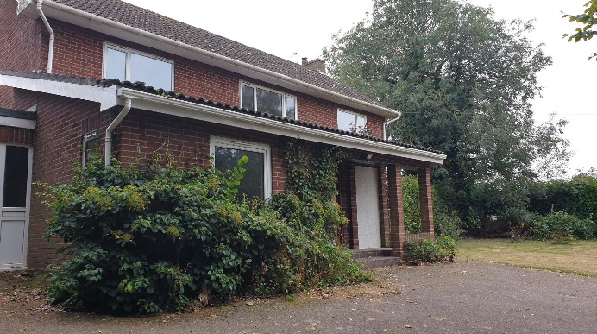 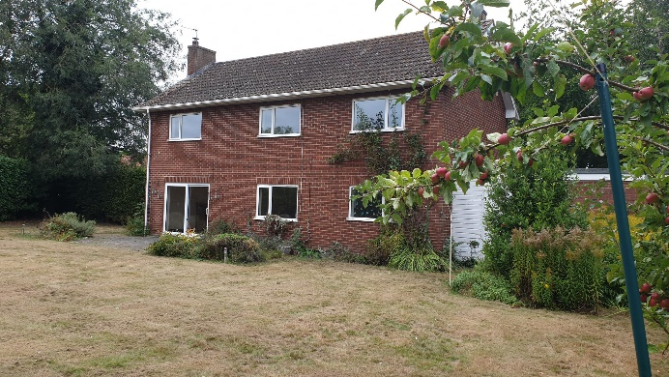

**The Vicarage** is a very attractive detached house with a good-sized lounge, separate dining room, study, downstairs cloakroom, four bedrooms, double garage and large, secluded rear garden and views over open fields to the front.

The Benefice lies on both sides of the A47 in central Norfolk making access to most parts of our beautiful county straightforward. The River Tud flows from near Dereham to join the River Wensum northwest of Norwich and runs through the northern part of the benefice. There are many and varied walking routes around the benefice.

Supermarkets and other facilities are within easy reach by car or bus.

Children are well served with nursery and primary schools. There are two good church schools, in Hockering and Yaxham and the larger Mattishall Primary. Secondary age children go to High Schools in Dereham, Costessey or Wymondham. Further and Higher Education is provided by Dereham Sixth Form College, Norwich City College, Easton College, University of East Anglia and Norwich University of the Arts, amongst others.

Norfolk has nature in abundance with a wide variety of specialist sites and sights, including the Broads National Park, other attractions and a large number of beautiful beaches. There is Championship football in Norwich and numerous other sporting activities. A range of theatres, music festivals, restaurants, historic properties, museums and more medieval churches per acre than anywhere else in Europe make this a superb place to live.

The River Tud runs from Dereham to Norwich where it joins the Wensum. A Cluster Group of landowners and farmers whose land is situated along the River Tud valley has been formed to enhance water quality and nature recovery.

## BENEFICE MAP

## PARISH DETAILS

### All Saints’, East Tuddenham

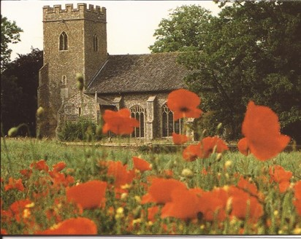East Tuddenham is a very rural parish and has a population of approximately 520. There are no shops in the village, but nearby Mattishall has a medical practice and a post office. There is however an excellent village hall in East Tuddenham which caters for varied groups within the village and is also available for hire. There is a good bus service to Dereham/Norwich which runs through the village every hour.

Ailwyn Hall Care Home is close by and the Ministry Team lead some services there as and when requested. There are two therapeutic homes with schooling for children and teenagers which are managed by Childhood First and Norfolk County Council. East Tuddenham Charities run two blocks of alms-houses.

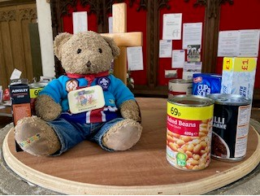The church, which is near the edge of the village is medieval and very beautiful, parts of it dating back to the late 12th century and is of mixed styles as it has been altered and added to throughout the centuries. It is in a fairly good state of repair. There is no water laid on and the heating is by electric wall heaters. There is no amplification system installed, but we do have an amp and microphone.

We have 3 on our electoral roll for 2024 and our average Sunday attendance is 2.

We have a service of Holy Communion on the first Sunday, and Morning Worship on the third Sunday. Our services are based on Common Worship and use the Complete Mission Praise.

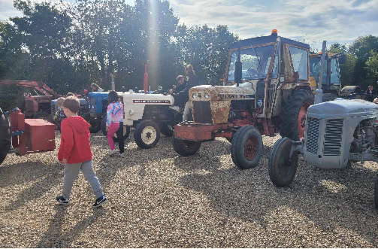We recognise the importance of meeting the Parish Share in full.

The village produces a monthly newsletter, the Parish Pump, which is delivered to all the houses in the villages of East Tuddenham and Honingham. We use this to give our list of services.

### St Michael’s, Hockering

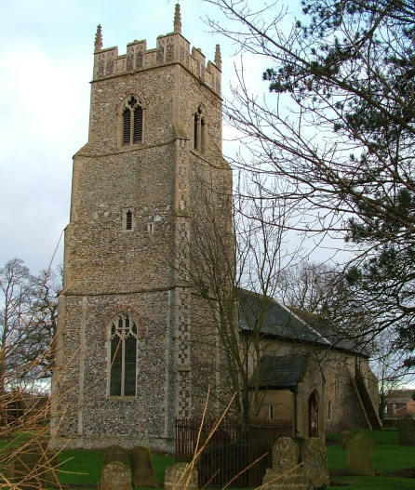With a regular congregation of around 6, St Michael’s holds a service 3 out of 4 Sundays at 9am, using Common Worship and a mix of modern and traditional hymns, including congregation-led services held on the 4th Sunday of the month. There have been three funerals and one Baptism at St. Michael’s in the past 12 months.

Since raising a lot of funds towards a substantive building programme that was completed in 2012, members of the congregation have continued to be active and successful in raising funds for the church, the main event being monthly coffee mornings (10 months of the year) which have the added benefit of providing a regular link and support from the village community. However, it is noted that there is still some building work required as highlighted in a recent Quinquennial Inspection.

We are well supported at our monthly Coffee Mornings by village members and regular visitors from other parts of the Benefice. We are very grateful to the Parish Council who usually send representatives to the Coffee Mornings as a point of contact for the village, and also to the Hockering Town Lands and Poor Lands Charity for their continued financial support. There is also a yet-to-be-established Community Coffee Morning twice a month on Wednesdays in the Village Hall.

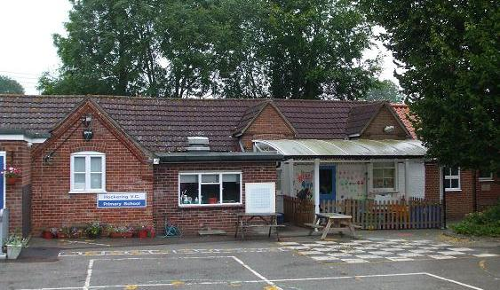Hockering is proud of its Church of England Primary Academy school which is a member of the Eden Federation of Church Academies. The last Ofsted report declared it to be a ‘Good School’. The church has good links with the school, with several of the Benefice staff assisting with Collective Worship on a regular basis and it is hoped this will continue. 31 pupils are expected to attend the school in September 2024. The school also has services in St. Michael’s on a termly basis.

Recently the school took part in the Eco-Angel Pilgrim Trail involving 12 churches in the Diocese, making their own ‘Eco Angel’. A life size “WALL-E” now stands in the porch of St. Michael’s church.

Hockering is divided by the A47, with a few houses to the South. There have been a lot of new houses built in the village over the past few years including a site to the South-East of the Village. We are also on the verge of the beginning of the A47 upgrade to dual the carriageway from Easton to Dereham and this is bound to impact the village whilst the works are carried out, but should benefit the village in the long term. According the 2021 Census, Hockering has approximately 860 residents in a mix of housing types, but this has increased due to new housing that has been built. Hockering also has a well-used village hall, public house, garage and general provisions shop and a playing field with active football teams. The former Rectory is retained by the Diocese and was home to a Curate for the Benefice and her family, but who moved on to her own Benefice in September 2024.

The churchyard is well maintained and still used by the village.

Our record for paying the Parish Share contribution towards the Benefice Share has been good in previous years, but we have lately struggled mostly due to the cost of living crisis but also with the loss of some of our regular parishioners.

***Hockering School – the children’s ideas on an ideal new Rector***

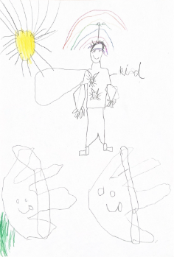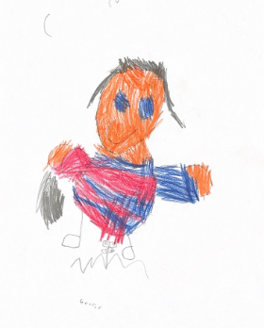

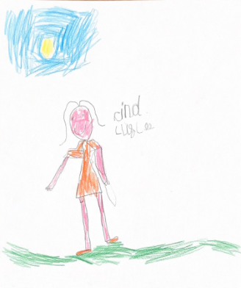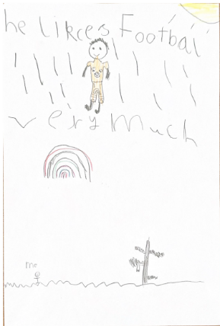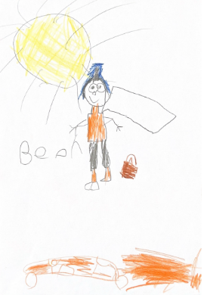

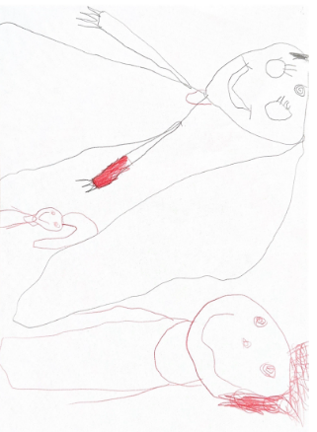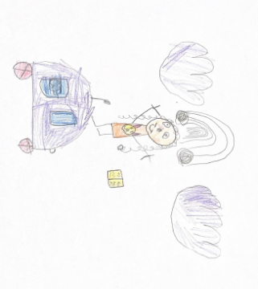

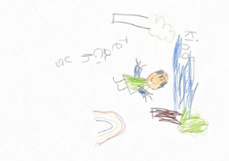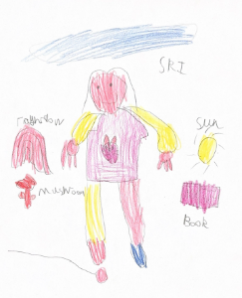

### All Saints’, Mattishall and St Peter’s, Mattishall Burgh

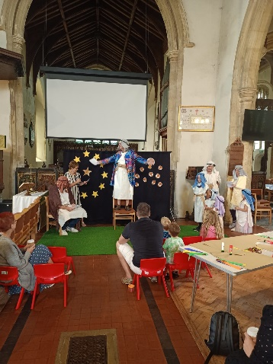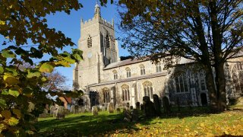**Worship**

All Saints’ Mattishall is a welcoming church in the centre of the large, growing village of Mattishall.

Mattishall is a large, expanding village with a population of 2744 (Census 2021) in a variety of housing. Its shops and facilities serve much of the local area. There is a GP surgery, a pharmacy, a Post Office, a newsagent, a grocery shop, a pub, a fish 'n' chips shop and several hairdressers. There is also a farm shop. An hourly bus service into Norwich and Dereham operates into the evenings and runs every day.

There is a large Primary School and three private day nurseries as well as Guide and Scout Association groups based in the village. The Primary School has pre and after school clubs. The village also has a sports and social club, a local training centre which has a café and gym, and a golf club. In addition to the open churchyard at St Peter’s there is a public cemetery, next to which are public allotments. There are many trades people, including a car mechanic and an expert in church repairs. There are also Methodist and Evangelical churches which together with All Saints form a Churches Together, coming together and organising a Good Friday March of Witness and an annual Village Green Service.

We have two Sunday congregations who get on well and work together. At 9.00 we offer a more traditional service using Common Worship liturgy and hymns accompanied by the organ (average congregation-12 adults). On the first Sunday of the month a “Sunday Special” service is run by the 9.00 congregation. The 10.30 service is more informal in style (average congregation 22 adults and 2 under 16’s). The music is provided by a gifted group of musicians and singers or via the audio-visual system. There is a strong desire for challenging Bible-based teaching and prayer. The 10.30 service has a charismatic heritage where exercising gifts of the Spirit with integrity is encouraged and there are opportunities for prayer ministry. It is hoped that ministry in the Holy Spirit will continue to be encouraged and developed. We have been members of the Evangelical Alliance for many years.

Presently both congregations are comprised of more mature people with only a couple of young families at the 10.30 service. Children’s church is therefore not offered but activities and toys are available. We have a real desire to reach families, but have been unable to attract any to our Sunday morning services.

Also, Holy Communion is celebrated from time to time at the Bob Carter Court sheltered housing.

St. Peter’s church building on the edge of Mattishall, though it has the open churchyard mentioned earlier, is itself not in use.

**Outreach**

**“Oasis”** is run on a Sunday afternoon 4-5.30pm once a month. It is informal and aimed at families with children up to about School Year 6. It draws in families from around the benefice and from outside. It is led by a lay team and comprises crafts, a dramatised Bible story, action songs and is followed by afternoon tea. It has been well received and has built on the other family outreach activities we offer, such as Little Angels and Who Let The Dads Out? (Oasis has had an average attendance 12 adults, 15 children plus the team).

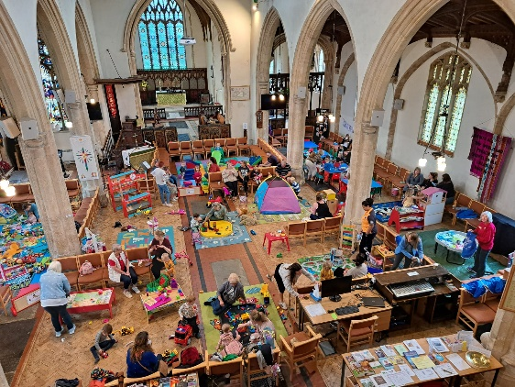

“**Little Angels**” meets weekly in All Saints’ church during term time and is a parent and children’s group for pre-school children. A craft and Bible story are provided for those who would like to participate alongside many play activities and toys. We recently ran a Hope Explored course during the sessions. It draws in families from around the benefice and from outside. Weekly we have around 25 families attending.

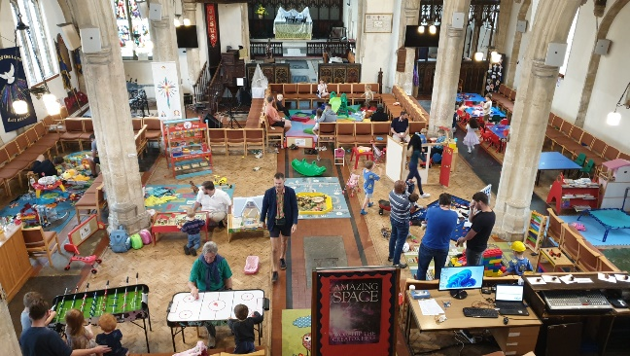On the first Saturday of the month “**Who Let the Dads Out?**” meets in All Saints’ church. It is for dads (and other dads) with their children of school year 2 and younger. Again, it draws in families from around the benefice and beyond (with an average of 11 dads and 17 children per session). It provides an opportunity for fun through play, games and crafts and to connect as well as enjoy a bacon roll! Unlike Little Angels and Oasis, the crafts are not Bible-based, but some connections to the Christian faith and church seasons are made.

Other family activities we provide are the annual Bright Party on 31st October each year. This is a Christian alternative to Halloween and attracts 90-140 adults and children. The Easter Treasure Trail finishes in All Saints’ church with crafts relating to the Easter Story. The Christmas Activities afternoon, where we partner with the Parish Council, also comprises crafts and refreshments. Both are also well attended.

**“Drop In”** meets weekly on Thursdays. It is a social coffee morning, open to all, held in All Saints’ church. It generally attracts 25-30 older members of the community and provides an opportunity for relaxed fellowship and informal pastoral support. It is particularly valued by those who are more socially isolated in the community.

**“Singing for Wellbeing”** meets twice a month. It is an informal community choir. Its aim is for everyone to leave with a smile on their face. A book club meets monthly and is a social event.

We are fortunate that All Saints’ Church was re-ordered some years ago, so we have a flexible space in which to run church services and events. We have a toilet and servery as well as chairs rather than pews. We have plans to add in another toilet, to improve the servery area and to provide more storage, however owing to financial constraints, COVID 19 and other factors including more pressing essential maintenance, this project has been “put on the back burner.” We are also blessed to have active church family members who are committed and willing to help with events and to draw people to Christ.

**Prayer and Discipleship**

We are committed to prayer as a church and have two regular weekly prayer times. We also prioritise Bible teaching and run 5 home groups, including a Men’s Group which meets online once a fortnight. Some former members of our congregations, who are house-bound or unable to attend church, access some of these groups maintaining fellowship and a sense of belonging.

We also have occasional interactive teaching sessions led by Rev. Dr. Sue Woan with the latest one being “From-scroll to best-selling paperback”- the adventures behind how we got our Bible. These sessions are suitable for all ages and open to the benefice as well as people from other churches. We also have a book exchange table where books and other resources may be borrowed or taken.

Quiet mornings are a newer initiative led by our AWA. We hope these will become a termly feature. They are open to the whole benefice.

There is also a monthly Men’s Breakfast and a Ladies’ Coffee afternoon which are social events held in local cafes.

**Mission Partners**

We support our mission partners North Breckland Youth for Christ, the Mid-Norfolk Foodbank, Missionary Aviation fellowship and Open Doors through tithing 10% of the income of the PCC. We also make regular donations of food to the foodbank and at Harvest.

**Finance**

We are committed to paying our parish share in full and our guiding principle is that we do not fundraise outside of the church family for Kingdom work though we have received outside grants for repairs to the building. Regular giving using tithing principles is encouraged through teaching.

Mattishall has 2 other church buildings which it maintains besides the large mediaeval church of All Saints’. We look after the small St Peter’s Church which is located within the parish. It is unused as a church building, but has an open churchyard. We also look after and pay for the Church Rooms which are used by outside organisations such as the Guide Association, and are hired out for events.

Located next to the Mattishall Church Rooms is the Benefice Office. Our part-time Benefice Administrator is based there and faithfully serves the whole benefice and is funded by all of the parishes in the benefice.

### St Mary's, North Tuddenham

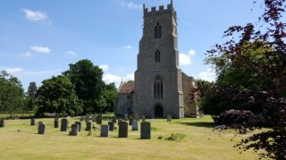The village is to the north of the benefice, large in area, but is a scattered and fragmented parish, bisected by the A47, with the population of some 350 souls. It has a thriving pub -The Lodge, a garage, farm shop and a village hall.

The church of St. Mary's is to the east of the village standing isolated overlooking the River Tud Valley and dates to circa 1360. We have two services a month, a Morning Worship on the first Sunday of the month and a Holy Communion on the third, singing traditional hymns from Hymns Ancient & Modern and often accompanied by the church organists. The average congregation is 6- 8 throughout the year, but this number swells to 20 -30 at our festivals.

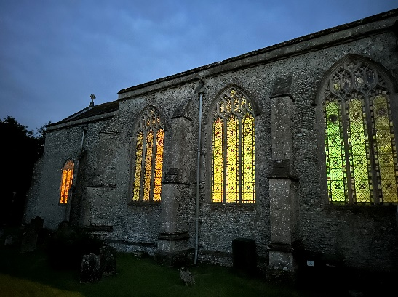The church is recognised and treasured for its stained-glass windows, some with medieval glass and its rood screens. The unique Victorian wall tiling and Bevington windpipe organ are also notable.

St Mary’s underwent significant and expensive repair work to its tumbling tower between February 2019 and October 2022. The remedial work itself involved restoring the buttresses, masonry work, underpinning and upgrading surface water drainage. The project was mainly funded by Historic England, other religious charities and by the local community. Restoration of the stained-glass window in the tower, featuring sections of medieval glass, was completed in July 2023.

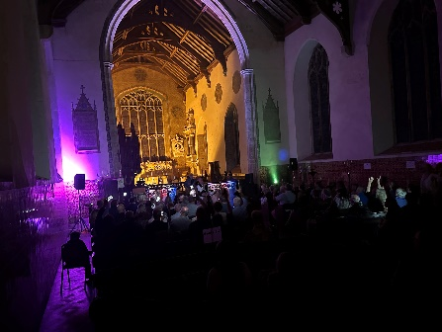In addition, maintenance work over the last 10 years to the bell, improving heating & lighting and restoring the windpipe organ, has been a considerable drain on financial resources, but the church is now structurally sound and architecturally beautiful.

St Mary’s had always paid its Parish Share through activity-based events, but when these ceased in 2019, other ways had to be found to raise money. Blessed by the wonderful acoustics in the nave, the PCC decided to build on St Mary’s growing reputation as a music venue by organising a range of concerts of an eclectic nature during the summer months. These have proved very popular.

St Mary’s is a large church with a small, but friendly congregation which always welcomes visitors and people to its services and musical events with a smile.

### All Saints’, Welborne

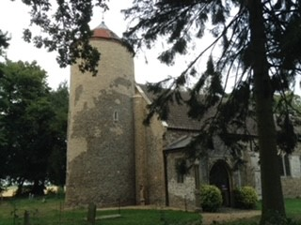Welborne is a small rural hamlet of about 220 people situated between Mattishall and Barnham Broom and is about 12 miles West of Norwich. The Saxon Church and Victorian village hall, which was originally the school, are situated very close to one another and adjoin the Old Rectory which is now a flourishing residential care home, known as Nightingale, at which monthly Services are held.

The village age profile tends towards the retired although a number of residents are employed at the UEA, N&N hospital, the care home industry and agriculture. Families look towards Dereham and Wymondham for day to day supplies although Mattishall, about 1 mile distant, has two well stocked local shops, a hairdresser, a Surgery and Pharmacy, and a primary school. From Mattishall, there is an hourly bus service to Norwich and Dereham which also serves the hospital.

The Church family normally comprises a congregation of 12-14 although only 4 of these actually come from within the village of Welborne. Services are held weekly at 9am with Communion once a month and a DIY Service, led by the Church Warden, on another Sunday. The Church family carries out many of the regular duties including cleaning, service preparation and post Service coffee. The mowing upkeep of the original churchyard is carried out by village volunteers. The cemetery is maintained by a local contractor. The Church fabric is in very good order following a recent grant of £250,000 by the Heritage Lottery Fund. The organ was completely renovated a few years ago following a generous gift by a member of the congregation. The major structural works to the tower funded by the Lottery, also included the provision of a kitchenette and cloakroom facilities. Three members of the congregation attend to many of the day to day repairs, resulting in most of the quinquennial list being completed at nil or very low cost. Financially the Church is in reasonable order and has paid all its share until this year when there will be a shortfall

.

|  |  |  |
| --- | --- | --- |
|  |  |  |

Reference has already been made to the fact that only 4 members of the congregation come from within the village boundary. However, there is an active Village Hall Committee which raises cash for village events including a biennial beer festival, quiz nights, winter film shows, Christmas fayre, and other village initiatives all aimed at bringing the community together in the dark months. There has been more “working together” recently, but it should be regarded as work in progress.

### St Peter’s, Yaxham

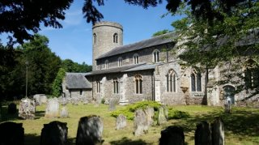Yaxham is a small rural village in the heart of Norfolk, 2 miles southeast of the market town of Dereham and 1 mile to the west of Mattishall. There are two adjoining settlements – Yaxham and Clint Green. It has an expanding population with new developments of about 860 people including a development of lodges with cafe. The rural village is mostly residential, surrounded by open countryside with the heritage railway running to the west of the village and the Tud valley to the north with areas of environmentally important meadows.

The medieval church of St Peter lies at the heart of the village conservation area close to the modern village hall, with excellent facilities such as the Jubilee Playing Field and young children’s play area. The 12th Century circular tower houses a Peal of 6 bells which are regularly rung, with a team of active bell ringers. The fine organ is used regularly at services and St Peter’s is open daily for visitors.

Following our last Quinquennial inspection, we are now starting a major project of restoration of the roof and installation of a toilet and refectory – Project Revive – to future proof the building and enable more outreach.

The Yaxham Church of England Primary Academy was recently rebuilt to accommodate 105 pupils. The school provides a nurturing environment that has been achieved by ensuring positive links between home, school and the church. Being part of DNEAT helps support the school’s development journey. It recently received a very positive SIAMS report, which stated that the core values of Love, Creativity and Perseverance are modelled by pupils.

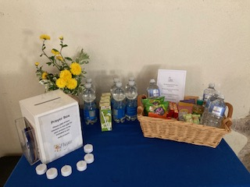The congregation is very welcoming, hospitable and faithful, with approximately 10 at each service, a small but regular and stable number. Our pattern of services is currently every other Sunday with a traditional style of common worship with regular evening prayers twice a month during the week. We have a warm church (good heating!) to invite others to join us. St Peter’s pay its Parish Share, uses the Parish Giving facility and tithes all giving annually to local charities.

The Benefice Assistant Priest, Rev Sally Thurgill, lives in Yaxham, as does the Licensed Lay Minister, Jackie Crisp and together they help define our activities and prayerful support to the community in which we live. Both are St Peter’s PCC members. We have a full and active PCC group, with 2 churchwardens, treasurer, chair, parish safeguarding officer and fabric officer. We are committed to ensuring the safety and wellbeing of children, young people and vulnerable adults and all relevant policies are displayed.

The Church fellowship believes that the future lies in developing prayer, lay ministry and pastoral care.

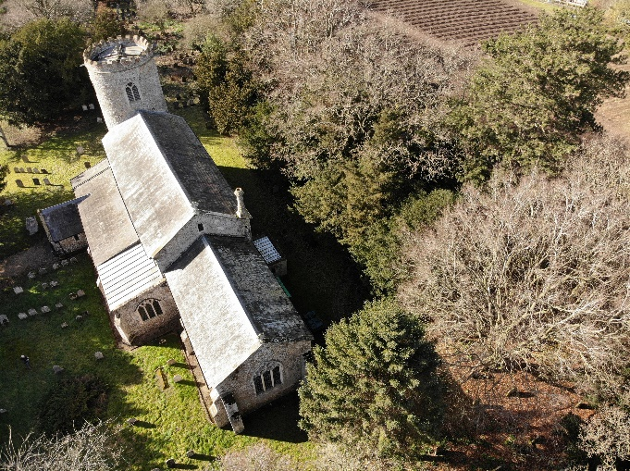

**Yaxham CE Primary Academy**

The local clergy have an established relationship with the school.

They are known by the pupils because of their weekly involvement in leading worship. Additionally, pupils visit the local church for celebration festivals such as Harvest in the school year. They warmly refer to it as ‘our church’. This partnership contributes to spiritual flourishing as it is a place of worship that pupils are familiar with and comfortable in.

SIAMS July 2024

At Yaxham we really value our connection with the benefice team who support us to live our Christian vision. Children have developed strong relationships as recognised in our recent SIAMS. Staff, children and families benefit greatly from support, especially during difficult times.

The children have reflected on their relationships and have thought about the qualities needed in a rector. They recognise the compassion shown as well as the role played in leading worship. They look forward to welcoming a new vicar to Yaxham.

|  |  |
| --- | --- |
|  |  |
|  |  |
|  | |

### Benefice, Diocese and National Statistics

Worshipping Community Age Spread & % attendance per capita:

|  |
| --- |
| Image |

Worshipping community age spread:

|  |
| --- |
|  |

Population Spread – proportional to worshipping community numbers:

|  |
| --- |
|  |

Population age spread:

|  |
| --- |
|  |