Morning Prayer for Christmas and Epiphany

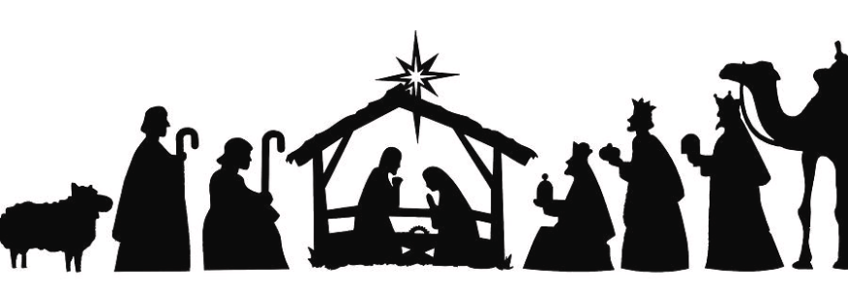

Seeking God Together

From Monday to Saturday every week, we gather together at 9am to hear God’s word and pray together.
We intercede on behalf of our villages and our world and we seek to hear God’s voice of guidance and blessing.

Christmas a celebration of the birth of Jesus Christ. However, it is also so much more. Christmas is also a Reminder of the central truth of the Word made flesh for our Salvation.
After The joyful celebration of Christmas, the churches year continues on into Epiphany. The visit of the magi is understood as the manifestation of Christ to the gentiles.
We invite you to join us via Zoom using these details:
Meeting ID: 835 1392 5378 Password: 858873
Or
Use this booklet and the daily readings for each day on your own at home.

Each Day focuses on a different village.
Mon – Hockering
Tues- Yaxham
Wed- Welborne
Thurs – East Tuddenham
Fri – North Tuddenham
Sat- Mattishall.

Prayer for Christmas
Preparation

O God make speed to save us.
O lord make haste to help us.

I will listen to what the Lord will say.
For he shall speak peace to his people and to the faithful.
Psalm 85:8

The Word of God
A psalm and one or more bible readings are used.
The word was made flesh and lived among us,
And we have seen his glory.

Prayers
Prayers may include these concerns: The church, especially in places of conflict; Rulers; especially in the Holy Land; Children, especially refugees and the vulnerable.

In our benefice please pray for the village allocated for today

The collect of the day or the following prayer is said.

Father of lights
From whom comes every good and perfect gift,
Keep us in the light of Christ,
To shine in your world,
That all may believe in you.
Through Jesus Christ our Lord
The promise of his glory. Amen

The Lord’s Prayer

Our Father in heaven,
Hallowed be your name,
Your kingdom come,
Your will be done,
On earth as it is in heaven.
Give us today our daily bread.
Forgive us our sins and we forgive those who sin against us.
Lead us not into temptation,
But deliver us from evil.
For the kingdom, the power and the glory are yours now and forever. Amen

The Conclusion

May the grace of our Saviour be with us all.
Amen.

Prayer for Epiphany
Preparation

O God make speed to save us.
O lord make haste to help us.

With you, O God, is the well of life,
And in your light shall we see light.

O continue your loving kindness to those who know you,
And your righteousness to those who are true of heart.
Psalm 36:9,10

The Word of God
A psalm and one or more bible readings are used.

Arise, shine, for your light has come;
The glory of the Lord is rising upon you.

Prayers
Prayers may include these concerns: The church, especially in places of conflict; Rulers; especially in the Holy Land; Children, especially refugees and the vulnerable.

In our benefice please pray for the village allocated for today

The collect of the day or the following prayer is said.
Almighty God,
Your Son Jesus Christ is the light of the world.
Grant that your people may shine with the radiance of his glory,
That he may be known, worshipped, and obeyed to the ends of the earth,
Now and forever. Amen

The Lord’s Prayer

Our Father in heaven,
Hallowed be your name,
Your kingdom come,
Your will be done,
On earth as it is in heaven.
Give us today our daily bread.
Forgive us our sins and we forgive those who sin against us.
Lead us not into temptation,
But deliver us from evil.
For the kingdom, the power and the glory are yours now and forever. Amen

The Conclusion

May the light of Christ our Lord shine in all our hearts. Amen

Suggested readings for the seasons of Christmas and Epiphany

Date | Psalm | OT | NT | Notes
Mon 26th Dec | 119 | Genesis 4:1-10 | Acts 6 | St Stephen
Tues 27th Dec | 120 | Exodus 33:9-19 | John 13:21-35 | John apostle and evangelist
Weds 28th Dec | 132 | Jere 31:1-17 | Matthew 18:1-10 | The Holy innocents
Thurs 29th Dec | 19 | Isaiah 57:15-end | John 1:1-18 | Thomas Becket
Fri 30th Dec | 113 | Isaiah 59:1-15a | John1 :19-28
Sat 31st Dec | 102 | Isaiah 59:15b-end | John 1 29-34
Mon 2nd Jan | 18:1-30 | Isaiah 60: 1-12 | John 1:35-42
Tues 3rd Jan | 127 | Isaiah 60:13-end | John 1:43-end
Wed 4th Jan | 89:1-37 | Isaiah 61 | John 2:1-12
Thurs 5th Jan | 48 | Isaiah 62 | John 2:13-end
Fri 6th Jan | 132 | Jere 31:7-14 | John 1:29-34 | Epiphany
Sat 7th Jan | 99 | Isaiah 63:7-end | 1 John 3
Mon 9th Jan | 2 | Amos 1 | 1 Corinthians 1:1-17 | Epiphany 1
Tues 10th Jan | 9 | Amos 2 | 1Corinthians 1:18-end
Wed 11th Jan | 20 | Amos 3 | 1 Corinthians 2
Thurs 12th Jan | 21 | Amos 4 | 1 Corinthians 3 | Aelred of Hexham
Fri 13th Jan | 67 | Amos 5:1-17 | 1 Corinthians 4 | Hilary Bishop of Poitiers
Sat 14th Jan | 33 | Amos 5:18-end | 1 Corinthians 5
Mon 16th Jan | 146 | Amos 6 | 1 Corinthians 6:1-11 | Epiphany 2
Tues 17th Jan | 132 | Amos 7 | 1 Corinthians 6:12-end
Wed 18th Jan | 81 | Amos 8 | 1 Corinthians 7:1-24 | The
Thurs 19th Jan | 76 | Amos 9 | 1 Corinthians 7:25-end | week
Fri 20th ^{t} Jan | 27 | Hosea 1:1-21 | 1 Corinthians 8 | of
Sat 21st Jan | 122 | Hosea 2:2-17 | 1 Corinthians 9:1-14 | prayer
Mon 23rd Jan | 108 | Hosea 2:18-end of 3 | 1 Corinthians 9:15-end | for  (Epiphany 3)
Tues 24th Jan | 36 | Hosea 4 :1-16 | 1 Corinthians 10:1-13 | Christian
Wed 25th Jan | 66 | Ezekiel 3:22-end | Philippians 3:1-14 | unity (The conversion of Pau)l
Thurs 26th Jan | 47 | Hosea 5 :8-6:6 | 1 Corinthians 11:2-16 | Timothy and Titus
Fri 27th Jan | 65 | Hosea 6:7-7:2 | 1 Corinthians 11:17-end
Sat 28th Jan | 68 | Hosea 8 | 1 Corinthians 12:1-11 | Thomas Aquinas
Mon 30th Jan | 1 | Hosea 9 | 1 Corinthians 12:12-end | Epiphany 4
Tues 31st Jan | 93 | Hosea 10 | 1 Corinthians 13
Wed 1st Feb | 95 | Hosea 11:1-11 | 1 Corinthians 14:1-19
Thursday 2nd Feb | 48 | Exodus 13:1-16 | Romans 12:1-5 | The presentation of Christ in the Temple

